Preparing for A-Level French

**at the Ecclesbourne School**

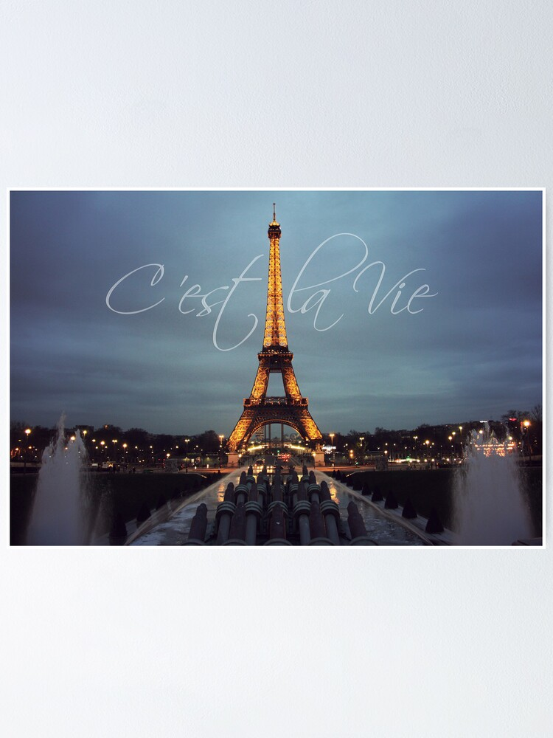

***Course information and preparatory activities***

***You will find more detail about the specification at:***

<https://www.aqa.org.uk/subjects/languages/as-and-a-level/french-7652>

Bring this booklet in school with you when we’re back in September.

**Topics we study in Year 12**

**1. Social issues and trends**

Students must study the following themes and sub-themes in relation to at least one French-speaking country. Students must study the themes and sub-themes using a range of sources, including material from online media.

**Aspects of French-speaking society: current trends**

Students may study all sub-themes in relation to any French-speaking country or countries.

**• The changing nature of family (La famille en voie de changement)**

• Grands-parents, parents et enfants – soucis et problèmes

• Monoparentalité, homoparentalité, familles recomposées

• La vie de couple – nouvelles tendances

**• The ‘cyber-society’ (La « cyber-société »)**

• Qui sont les cybernautes ?

• Comment la technologie facilite la vie quotidienne

• Quels dangers la « cyber-société » pose-t-elle ?

**• The place of voluntary work (Le rôle du bénévolat)**

• Qui sont et que font les bénévoles ?

• Le bénévolat – quelle valeur pour ceux qui sont aidés ?

• Le bénévolat – quelle valeur pour ceux qui aident ?

**2. Political and artistic culture**

Students must study the themes and sub-themes below in relation to at least one French-speaking country.

**Artistic culture in the French-speaking world**

Students may study all sub-themes in relation to any French-speaking country or countries.

**• A culture proud of its heritage (Une culture fière de son patrimoine)**

• Le patrimoine sur le plan national, régional et local

• Comment le patrimoine reflète la culture

• Le patrimoine et le tourisme

**• Contemporary francophone music (La musique francophone contemporaine)**

• La diversité de la musique francophone contemporaine

• Qui écoute et apprécie cette musique ?

• Comment sauvegarder cette musique ?

**• Cinema: the 7th art form (Cinéma : le septième art)**

• Pourquoi le septième art ?

• Le cinéma – une passion nationale ?

• Evolution du cinéma – les grandes lignes

**Topics we study in Year 13**

**1. Social issues and trends**

Students must study the following themes and sub-themes in relation to at least one French-speaking country. Students must study the themes and sub-themes using a range of sources, including material from online media.

**Aspects of French-speaking society: current issues**

Students may study all sub-themes in relation to any French-speaking country or countries.

**• Positive features of a diverse society (Les aspects positifs d’une société diverse)**

• L’enrichissement dû à la mixité ethnique

• Diversité, tolérance et respect

• Diversité – un apprentissage pour la vie

**• Life for the marginalised (Quelle vie pour les marginalisés ? )**

• Qui sont les marginalisés ?

• Quelle aide pour les marginalisés ?

• Quelles attitudes envers les marginalisés ?

**• How criminals are treated (Comment on traite les criminels)**

• Quelles attitudes envers la criminalité ?

• La prison – échec ou succès ?

• D’autres sanctions

**2. Political and artistic culture**

Students must study the themes and sub-themes below in relation to at least one French-speaking country.

**Aspects of political life in the French-speaking world**

Students may study all sub-themes in relation to any French-speaking country or countries.

**• Teenagers, the right to vote and political commitment (Les ados, le droit de vote et l’engagement politique)**

• Pour ou contre le droit de vote ?

• Les ados et l’engagement politique – motivés ou démotivés ?

• Quel avenir pour la politique ?

**• Demonstrations, strikes – who holds the power? (manifestations, grèves – à qui le pouvoir ? )**

• Le pouvoir des syndicats

• Manifestations et grèves – sont-elles efficaces ?

• Attitudes différentes envers ces tensions politiques

**• Politics and immigration (La politique et l’immigration)**

• Solutions politiques à la question de l’immigration

• L’immigration et les partis politiques

• L’engagement politique chez les immigrés

**Grammar we study at A-Level**

There will be a real focus on grammar during Year 12. The aim is to enrich the quality and variety of your written and spoken French. You will have to organise carefully the sheets you are given. Increased knowledge of grammar allows you to say what you want to say. It is vital to success at A-Level. By the end of the course you will have mastered the following grammatical items:

**Nouns**

* Gender
* Singular and plural forms

**Articles**

* Definite, indefinite and partitive

**Adjectives**

* Agreement *(les problèmes sociaux… – social problems…)*
* Position *(un chat noir, un grand bâtiment… – a black cat, a big building…)*
* Comparative *(plus grand que, meilleur que, moins bon que… – bigger than, better than, less good that…)*
* Superlative *(le plus grand, le meilleur, le pire… – the biggest, the best, the worst…)*
* Demonstrative *(ce, cet, cette, ces… – this, these…)*
* Indefinite *(autre, chaque, même, quelque… – other, each, same, some…)*
* Possessive *(mon, ma, mes, ton, ta, tes... – my, your…)*
* Interrogative and exclamatory *(quel, quelle, quels, quelles – what, which, whose)*

**Numerals**

* Cardinal *(un, deux… – one, two…)*
* Ordinal *(premier, deuxième… – first, second…)*
* Expression of time and date

**Adverbs**

* Formation and endings *(rarement, lentement… – rarely, slowly…)*
* Negative *(ne _ pas, ne _ que, ne _ jamais, ne _ plus… – not, only, never, no longer…)*

**Pronouns**

* Subject *(je, tu, il/elle/on, nous, vous, ils/elles – I, you, he/she/you/we, we, you, they)*
* Direct object *(je le vois, je les achète… – I see him, I buy them…)*
* Indirect object *(je lui parle, je leur téléphone… – I speak to him, I call them…)*
* Disjunctive *(avec moi, pour toi, sans lui, avec elle… – with me, for you, without him, with her…)*
* Position and order of pronouns
* Reflexive *(me, te, se, nous, vous – myself, yourself, himself, herself, ourselves, yourselves, themselves)*
* Relative *(qui, que, dont, lequel, auquel, ce qui, ce que… – who, that, of which, that which, what…)*
* Demonstrative pronouns *(celui, celle, ceux, celui-ci, celui-là… – the one, the ones, this one, that one…)*
* Indefinite *(quelqu’un, quelque chose… – someone, something…)*
* Possessive *(le mien, la mienne, le tien, la tienne… – mine, yours…)*
* Interrogative *(qui, que, quoi… – what, which, who…)*
* Use of y, en

**Verbs**

* Impersonal verbs *(il est nécessaire de, il faut… – it is necessary to, one must…)*
* Dependent infinitives *(faire réparer… – to get _ repaired…)*
* Present tense - whole paradigms, including irregular forms
* Perfect tense - with the auxiliaries avoir and être *(j’ai mangé, je suis allé(e)… – I’ve eaten, I went…)*
* Imperfect tense *(je jouais… – I used to play / I was playing)*
* Future tense *(Quand j’aurai vingt ans, je serai étudiant… – When I’m twenty, I’ll be a student…)*
* Conditional tense *(je serais… – I would be…)*
* “Si” clauses - all 3 types *(si je suis libre je viendrai, si j’étais riche j’habiterais à Paris, si j’avais su je serais parti… – if I’m free I’ll come, if I were rich I would live in Paris, if i’d known I would have left…)*
* Pluperfect tense *(il avait dit, nous avions décidé… – he had said, we had decided…)*
* Future perfect tense *(j’aurai écrit, elle sera arrivée… – I will have written, she will have arrived…)*
* Conditional perfect tense *(ils auraient acheté… – they would have bought…)*
* Past historic
* The subjunctive mood
* Present participle *(en arrivant, en jouant… – when arriving, by playing…)*
* Passivevoice *(Les hommes ont été arrêtés… – The men were arrested…)*
* The government of verbs *(decider de faire, aider à faire… – to decide to do, to help to do…)*

**Conjunctions**

* Coordinating conjunction *(mais, ou, et… – but, or, and…)*
* Subordinating conjunction *(comme, puisque, donc, si… – like, since, therefore, if…)*

**Other construction**

* Prepositions
* Indirect speech *(Il a dit qu’il était libre… – He said he was free…)*
* Time expressions with depuis and il y a *(depuis deux ans, il y a trois mois – for two years, three months ago…)*
* Discourse markers *(au contraire, en fait… – on the contrary, in fact…)*

**Common mistakes**

Below is a list of common difficulties which Year 12 students often make:

|  |  |
| --- | --- |
| **These subjects are followed by…** | **… a verb in 3rd person singular (il/elle/on)** |
| Tout le monde *(everybody)*…  La police *(the police)*…  Le gouvernement *(the government)*…  Le grand public *(the general public)*…  Ma famille *(my family)*… | …sait qu’il a triché *(knows he cheated)*  …a réagi de façon très violente *(reacted very violently)*  …a annoncé une nouvelle loi *(has announced a nez law)*  …n’accepte pas la situation *(doesn’t accept the situation)*  …est très solidaire *(is very united)* |
| **These subjects are followed by…** | **…a verb in 3rd person plural (ils/elles)** |
| La plupart des français *(most French people)*…  10% des Britanniques *(10% of British people)*…  Beaucoup de gens *(lots of people)*…  Trop de jeunes *(too many young people)*… | …prennent leurs vacances au mois d’août *(take their holidays in August)*  …font leurs courses en ligne *(do their shopping online)*  …sont contre le mariage pour tous *(are against same-sex marriage)*  …passent beaucoup de temps rivés à leurs portable (*spend a lot of time riveted to their phone)* |

**How you are assessed at the end of your A-Level**

***Assessments at a glance***

**Paper 1: Listening, reading and writing**

|  |
| --- |
| **What’s assessed**  • Aspects of French-speaking society: current trends  • Aspects of French-speaking society: current issues  • Artistic culture in the French-speaking world  • Aspects of political life in the French-speaking world  • Grammar |
| **How it’s assessed**  • Written exam: 2 hours 30 minutes  • 100 marks  • 50% of A-level |
| **Questions**  • Listening and responding to spoken passages from a range of contexts and sources covering different registers and adapted as necessary. Material will include complex factual and abstract content and questions will target main points, gist and detail. Studio recordings will be used and students will have individual control of the recording.  All questions are in French, to be answered with non-verbal responses or in French (30 marks).  • Reading and responding to a variety of texts written for different purposes, drawn from a range of authentic sources and adapted as necessary. Material will include complex factual and abstract content and questions will target main points, gist and detail.  All questions are in French, to be answered with non-verbal responses or in French (50 marks).  • Translation into English; a passage of minimum 100 words (10 marks).  • Translation into French; a passage of minimum 100 words (10 marks).  No access to a dictionary during the assessment. |

**Paper 2: Writing**

|  |
| --- |
| **What’s assessed**  • One text and one film or two texts from the list set in the specification  • Grammar |
| **How it’s assessed**  • Written exam: 2 hours  • 80 marks in total  • 20% of A-level |
| **Questions**  • **Either** one question in French on a set text from a choice of two questions and one question in French on a set film from a choice of two questions **or** two questions in French on set texts from a choice of two questions on each text.  • All questions will require a critical appreciation of the concepts and issues covered in the work and a critical and analytical response to features such as the form and the technique of presentation, as appropriate to the work studied (eg the effect of narrative voice in a prose text or camera work in a film).  No access to texts or films during the assessment.  No access to a dictionary during the assessment.  Students are advised to write approximately 300 words per essay. |

**Paper 3: Speaking**

|  |
| --- |
| **What’s assessed**  • Individual research project  • One of four themes ie Aspects of French-speaking society: current trends, Aspects of French-speaking society: current issues, Artistic culture in the French-speaking world, Aspects of political life in the French-speaking world |
| **How it’s assessed**  Oral exam: 21–23 minutes (including 5 minutes preparation time)  • 60 marks in total  • 30% of A-level |
| **Questions**  • Discussion of a sub-theme with the discussion based on a stimulus card (5–6 minutes). The student studies the card for 5 minutes at the start of the test (25 marks).  • Presentation (2 minutes) and discussion (9–10 minutes) of individual research project (35 marks).  No access to a dictionary during the assessment (including 5 minutes preparation).  Students may take the assessment only once before certification.  Assessments will be conducted by either the centre or a visiting examiner and marked by an AQA examiner. |

**How you are assessed at the end of your A-Level**

***Assessments in detail***

**Paper 1: Listening, reading and writing**

Duration: 2 hours 30 minutes; total raw mark: 100

**Listening and responding**

Students will listen to spoken passages from a range of contexts and sources, covering different registers and types. The content of the passages will be based on the themes and sub-themes in this specification.

Questions will target main points, gist and detail and will require either non-verbal responses or responses in French. Questions will include the need to infer meaning and will include abstract material such as opinions, views, emotional reactions and personal experiences.

For one question students will need to summarise in French what they have understood from the passage they have heard and marks will be awarded for the quality of French used. Students must write in full sentences and use their own words as far as possible in this question.

In the remaining questions requiring a response in French, students should give only the information required by the question.

Across the passages for listening, reference will be made to at least two French-speaking countries other than France.

At least one passage will involve more than one speaker. Passages will be studio recorded and recordings provided to schools and colleges. Students will have individual control of the recording.

**Reading and responding**

Students will read a range of stimulus texts adapted from authentic sources, including online sources. Texts will include contemporary and historical material and will cover non-fiction and literary fiction and/ or material based on literature. The content of the stimulus texts will be based on the themes and subthemes in this specification, except in the case of literary texts where the content may fall outside of these themes and sub-themes.

Questions will target main points, gist and detail and will require either non-verbal responses or responses in French. Questions will include the need to infer meaning and will include abstract material such as opinions, views, emotional reactions and personal experiences.

For one question students will need to summarise in French what they have understood from the stimulus text they have read and marks will be awarded for the quality of French used. Students must write in full sentences and use their own words as far as possible in this question.

For the remaining questions requiring a response in French, students should give only the information required by the question.

Across the stimulus texts for reading, reference will be made to at least two French-speaking countries other than France.

**Assessment**

In questions requiring a summary, the marks for content (AO1 or AO2) and language (AO3) are awarded independently.

Long summaries will be marked for content (AO1 or AO2) or language (AO3) until the first natural break (usually the end of a sentence or main clause) between 90 and 100 words. Short summaries are not subject to an automatic penalty but in practice are unlikely to include all the required content points and will therefore be self-penalising.

The AO1 or AO2 mark is awarded for content points which contain the required information regardless of whether those points are expressed in the student’s own words, or are partly or wholly lifted from the recording or text. However, no AO1 or AO2 mark will be awarded for a content point where the student includes irrelevant material or copies inappropriately from the stimulus, eg by ‘lifting’ an element from the original which does not match the phrasing of the bullet point. Examples of this are in the specimen mark scheme. ‘Lifted’ language will not be eligible for credit when the AO3 mark is awarded.

In comprehension questions with no AO3 marks, where the natural answer to a question consists entirely or partly of words or phrases from the recording or text, students may use that material without rephrasing it. Minor spelling errors which do not distort the meaning will be tolerated. However, the AO1 or AO2 mark will not be awarded for a response in which the student includes irrelevant material or copies inappropriately from the stimulus, eg by ‘lifting’ an element from the original which does not match the phrasing of the question set. Examples of this are in the specimen mark scheme.

**Translation**

Students will translate a passage of at least 100 words from French into English. The content will be based on the themes and sub-themes in this specification.

Students will translate a passage of at least 100 words from English into French. The content will be based on the themes and sub-themes in this specification and students will be provided with a supporting text in French, giving them some of the vocabulary and structures which they will need for the translation.

No dictionaries are allowed in this exam.

**Paper 2: Writing**

Duration: 2 hours; total raw mark: 80

Students will answer an essay question in French for each of the two works they have studied (this can be a book and a film, or two books). Students will have a choice of question on each book/film. All questions will be in French and will require a critical and analytical response.

Students will be advised to write approximately 300 words per essay. Everything that students write will be marked; there is no word limit. Students who write the recommended number of words will have access to the full range of marks.

No dictionaries are allowed in this exam.

Access to the books and films is not allowed in this exam.

**Paper 3: Speaking**

Duration: 21–23 minutes (including 5 minutes supervised preparation time); total raw mark: 60

The test will be in two parts. Part 1 will be the discussion of one sub-theme from those in this specification, lasting 5–6 minutes, and Part 2 will be the presentation and discussion of the student’s individual research project.

**Part one**

In Part one, the teacher-examiner gives the student two cards, following the sequencing table provided as part of the assessment material and avoiding the topic of the student’s individual research project. Each card is based on a sub-theme and the two cards are drawn from different themes. The student chooses one of the two cards.

The stimulus card will form the basis for the discussion. The content of each card will be based on one of the sub-themes in this specification. Cards will contain images, text and three questions. The teacher-examiner will ask the student the questions during the discussion.

The student must ask the teacher-examiner two questions arising from the material on the card.

To meet the requirement to ask questions, a student must seek information or an opinion. Asking for repetition or clarification will not meet the requirement. The student’s questions must contain a conjugated verb. Rephrasing or repetition of the printed questions will not meet the requirement. Sample questions are shown in the specimen mark scheme.

Students may make notes during the 5 minute supervised preparation time and may make reference to these notes during the discussion of the sub-theme. The notes should be stored securely in the centre until results day.

**Part two**

In Part two the student will present the findings of his or her research for up to two minutes. This will be followed by a discussion of the findings of the student’s research. Examples of the types of question the teacher-examiner will ask during the discussion of the project are included in the A-level French, German and Spanish Instructions for the Conduct of the Examinations at aqa.org.uk

Students will provide in advance on the Candidate Record form a list of headings to indicate the scope of their research and the sources used. Apart from the names of published sources, any headings must be in English. The teacher may help the student to complete the form. Students must use at least two sources and at least one of them must be an online source. Apart from the two required sources, any remaining sources and/or headings must not exceed 80 words. Sources could be visual, audio or written (in any combination) and must be capable of leading to findings that will form the basis of a 9–10 minute discussion.

Teachers are allowed to:

• provide suggestions for the subject of students’ individual research

• discuss, guide and advise students on their proposed project title (including language of the title) and the scope of the research

• correct the language of the project title where necessary

• give feedback to students on the extent to which their provisional titles will or will not meet the assessment criteria

• suggest sources of reference, including but not limited to websites, books and magazines

• provide support/guidance on research techniques, including how best to manage the storing and assimilation of knowledge and information that has been researched

• provide guidance on planning and timescales, including deadlines or milestones according to which research outcomes can be monitored and checked

• monitor students’ progress according to such deadlines or milestones

• provide general advice on the type of language which students might use in the presentation and discussion.

Teachers must not:

• provide the student with material that they have designed specifically for the student’s project

• download and give the student specific source materials or copied and pasted extracts

• provide specific advice on the language of the student’s presentation and discussion, apart from the language of the project title

• give feedback orally or in writing on any written notes, drafts or preparatory work produced by the student for the presentation or discussion

• give feedback orally or in writing on any oral practice presentation by the student, beyond informing the student if it exceeds 2 minutes.

General advice is defined as guidance which the teacher would include in the teaching and learning of the class and which would apply to all projects. Specific advice is defined as guidance which relates to a particular project and is tailored to an individual student or group of students.

During the presentation and discussion of their research project, students may only have access to their completed Candidate Record form. No other notes are allowed.

Speaking assessments will be conducted by either the school or college or a visiting examiner. All assessments must be recorded and a complete and unedited audio recording made available to AQA.

All assessments will be assessed by an AQA examiner.

A five-week window will be timetabled during April and May. All assessments must be conducted within this period.

The confidentiality of the assessment materials must be strictly maintained before and during the period of the assessments.

Access to dictionaries is not allowed at any time during the assessment or preparation time.

**How to bridge the gap between GCSE and A-Level**

At GCSE you were mainly (though not exclusively) reliant on pre-learnt phrases. Verb tenses were often simply items of vocabulary. At AS you need to move from this stage to creating your own spontaneous written and spoken French. They key to this is working hard both at the grammar which will give you the framework and by being proactive in acquiring vocabulary-that means taking notes and using a vocabulary booklet for instance. You will acquire new vocabulary rapidly if you read French regularly and are rigorous. You also need to participate in speaking exercises in class to practise speaking French spontaneously. You will learn it by doing it. It is a big gap to cross and you will need to work consistently but you will feel a real sense of accomplishment as you get to the other side.

**Verbs & vocabulary**

You will be given a vocabulary booklet at the beginning of the course containing the most important topic related vocabulary. Just as importantly you will also need to build up your own vocabulary, and you should use a sperate notebook for this. Whenever you come across a new verb you should write it down as well as the noun that stems from the verb (or vice-versa*). This will increase your ability to express yourself in French in more complex and varied ways. You should also practise conjugating new verbs you encounter in different tenses.

\**for example*

**évoluer** *(verb)* 🡪 to evolve, to develop

La chirurgie esthétique a beaucoup évolué – Plastic surgery has greatly developed

**l’évolution** *(noun, feminine)* 🡪 evolution, development

L’évolution de la chirurgie esthétique est très impressionnantes – The development of plastic surgery is very impressive

When you are translating, looking up a word or looking at a conjugation, make sure you use a good dictionary (Collins Robert) or a good online dictionary such as [www.wordreference.com](http://www.wordreference.com) and [www.linguee.com](http://www.linguee.com).

**Ideas and opinions**

Another aspect of the A-level course is the need to express ideas and opinions in French in both the speaking and the writing exam. A-level students often find this challenging because they often lack the ideas in English. You will greatly benefit from keeping up to date with current events both in the French speaking world in particular and from thinking critically and analytically about a variety of topics. Watch or listen to the news on a regular basis and try to decide what you think about the big issues.

**The present tense**

It is vital that you start the year with a good knowledge of the present tense verb forms. Most aspects of verb tenses and forms come from a thorough knowledge of the present tense in French.

At GCSE you might not have spent a great deal of time dedicated to verb forms in the present tense so the beginning of year 12 will focus on that aspect. If you put in the effort now it will make it easier for you to write and speak accurate French.

When you learn and practise the present tense paradigms make sure you know all parts of the verb, including the infinitive. The ‘nous’ form is essential for the imperfect and the ‘ils/elles’ form is essential for the subjunctive. A thorough knowledge of the infinitive is essential for the future and conditional tenses.

**The present tense**

An important thing to remember about the present tense in French is that there is only one present tense, as opposed to the English which has two (the simple present and the present continuous:

|  |  |  |  |  |
| --- | --- | --- | --- | --- |
| j’attends 🡪 | I wait |  | je joue 🡪 | I play |
| I am waiting | I am playing |

It is also important to know subject pronouns confidently:

|  |  |  |  |  |  |  |
| --- | --- | --- | --- | --- | --- | --- |
|  | **Français** | **Anglais** |  |  | **Français** | **Anglais** |
| **1st person singular** | **je** | **I** |  | **1st person plural** | **nous** | **we** |
| **2nd person singular** | **tu** | **You** *(singular/informal)* |  | **2nd person plural** | **vous** | **you** *(plural/formal)* |
| **3rd person singular** | **il / elle / on** | **he/she/you** *(indefinite)***/one** |  | **3rd person plural** | **ils / elles** | **they** *(masc/fem)* |

**Regular verbs endings**

|  |  |  |  |  |  |
| --- | --- | --- | --- | --- | --- |
|  | **Regular -ER verbs have the following endings:** |  | **Regular -IR verbs have the following endings:** |  | **Regular -RE verbs have the following endings:** |
| **1st pers. sg.** | je jou**e** |  | je fin**is** |  | je vend**s** |
| **2nd pers. sg.** | tu jou**es** |  | tu fin**is** |  | tu vend**s** |
| **3rd pers. sg.** | il/elle/on jou**e** |  | il/elle fin**it** |  | il/elle vend |
| **1st pers. pl.** | nous jou**ons** |  | nous fin**issons** |  | nous vend**ons** |
| **2nd pers. pl.** | vous jou**ez** |  | vous fin**issez** |  | vous vend**ez** |
| **3rd pers. pl.** | ils/elles jou**ent** |  | ils/elles fin**issent** |  | ils/elles vend**ent** |

|  |  |  |  |  |  |  |  |
| --- | --- | --- | --- | --- | --- | --- | --- |
| **Here is a list of regular -ER verbs used on French TV news last week:** | |  | **There are fewer regular -IR verbs. This is a list of common -IR verbs:** | |  | **There are far fewer regular -RE verbs. Here are a few:** | |
| gaspiller | *to waste, squander* |  | agir | *to act* |  | apprendre | *to learn* |
| sensibiliser | *to make aware* |  | abolir | *to abolish* |  | attendre** | *to wait for* |
| casser | *to break, to run riot* |  | choisir | *to choose* |  | défendre | *to defend, forbid* |
| se déplacer | *to move, to travel* |  | établir | *to establish* |  | entendre | *to hear* |
| endommager | *to damage* |  | grossir | *to gain weight* |  | prétendre | *to claim* |
| tourner au drame | *to take a dramatic turn* |  | maigrir | *to lose weight* |  | perdre | *to lose* |
| gérer* | *to manage* |  | réussir | *to succeed* |  | répondre | *to reply* |
| sous-estimer | *to underestimate* |  | réfléchir | *to think, reflect* |  | ** notice you do not say ‘attendre pour’ in French, using a preposition here would be a mistake | |
| ignorer | *to ignore* |  | se tenir au courant | *to keep up to date* |  |
| s’informer | *to inquire about* |  |  |  |  |

* ‘gérer’ has an accent change when conjugated in the present tense in a similar way to ‘espérer’

**Reflexive verbs**

A reflexive verb is a verb for which the subject is the same as the object. Reflexive verbs can be regular or irregular. Reflexive pronouns are always the same though. Here are examples of regular reflexive verbs.

|  |  |  |  |  |
| --- | --- | --- | --- | --- |
| **s’habiller** – to get dressed |  | **se demander** – to ask oneself |  | **s’endormir** – to fall asleep |
| je **m’**habille |  | je **me** demande |  | je **m’**endors |
| tu **t’**habilles |  | tu **te** demandes |  | tu **t’**endors |
| il/elle/on **s’**habille |  | il/elle **se** demande |  | il/elle **s’**endort |
| nous **nous** habillons |  | nous **nous** demandons |  | nous **nous** endormons |
| vous **vous** habillez |  | vous **vous** demandez |  | vous **vous** endormez |
| ils/elles **s’**habillent |  | ils/elles **se** demandent |  | ils/elles **s’**endorment |

**Useful irregular verbs**

|  |  |  |  |  |
| --- | --- | --- | --- | --- |
| **être** – to be | **avoir** – to have | **aller** – to go | **faire** – to do | **devoir** – to have to |
| je **suis**  tu **es**  il/elle/on **est**  nous **sommes**  vous **êtes**  ils/elles **sont** | j’**ai**  tu **as**  il/elle/on **a**  nous **avons**  vous **avez**  ils/elles **ont** | je **vais**  tu **vas**  il/elle/on **va**  nous allons  vous allez  ils/elles **vont** | je **fais**  tu **fais**  il/elle/on **fait**  nous **faisons**  vous **faites**  ils/elles **font** | je **dois**  tu **dois**  il/elle/on **doit**  nous **devons**  vous **devez**  ils/elles **doivent** |
| **vouloir** – to want | **pouvoir** – o be able to | **savoir** – to know | **connaître** – to know | **prendre** – to take |
| je **veux**  tu **veux**  il/elle/on **veut**  nous **voulons**  vous **voulez**  ils/elles **veulent** | je **peux**  tu **peux**  il/elle/on **peut**  nous **pouvons**  vous **pouvez**  ils/elles **peuvent** | je **sais**  tu **sais**  il/elle/on **sait**  nous **savons**  vous **savez**  ils/elles **savent** | je **connais**  tu **connais**  il/elle/on connait  nous **connaissons**  vous **connaissez**  ils/elles **connaissent** | je prends  tu prends  il/elle/on prend  nous **prenons**  vous **prenez**  ils/elles **prennent** |
| **écrire** – to write | **lire** – to read | **mettre** – to put (on) | **dire** – to say | **offrir** – to offer |
| j’écris  tu écris  il/elle/on écrit  nous **écrivons**  vous **écrivez**  ils/elles **écrivent** | je lis  tu lis  il/elle/on **lit**  nous **lisons**  vous **lisez**  ils/elles **lisent** | je **mets**  tu **mets**  il/elle/on **met**  nous mettons  vous mettez  ils/elles mettent | je dis  tu dis  il/elle/on **dit**  nous **disons**  vous **dites**  ils/elles **disent** | j’**offre**  tu **offres**  il/elle/on **offre**  nous **offrons**  vous **offrez**  ils/elles **offrent** |
| **vivre** – to live | **conduire** – to drive | **courir** – to run | **sortir** – to go out | **dormir** – to sleep |
| je **vis**  tu **vis**  il/elle/on **vit**  nous vivons  vous vivez  ils/elles vivent | je conduis  tu conduis  il/elle/on **conduit**  nous **conduisons**  vous **conduisez**  ils/elles **conduisent** | je **cours**  tu **cours**  il/elle/on **court**  nous **courons**  vous **courez**  ils/elles **courent** | je **sors**  tu **sors**  il/elle/on **sort**  nous **sortons**  vous **sortez**  ils/elles **sortent** | je **dors**  tu **dors**  il/elle/on **dort**  nous **dormons**  vous **dormez**  ils/elles **dorment** |
| **servir** – to serve | **tenir** – to hold | **venir** – to come | **voir** – to see | **boire** – to drink |
| je **sers**  tu **sers**  il/elle/on **sert**  nous **servons**  vous **servez**  ils/elles **servent** | je **tiens**  tu **tiens**  il/elle/on **tient**  nous **tenons**  vous **tenez**  ils/elles **tiennent** | je **viens**  tu **viens**  il/elle/on **vient**  nous **venons**  vous **venez**  ils/elles **viennent** | je vois  tu vois  il/elle/on voit  nous **voyons**  vous **voyez**  ils/elles **voient** | je bois  tu bois  il/elle/on **boit**  nous **buvons**  vous **buvez**  ils/elles **boivent** |
| **croire** – to believe | **acheter** – to buy | **espérer** – to hope | **gérer** – to manage | **nettoyer** – to clean |
| je crois  tu crois  il/elle/on **croit**  nous **croyons**  vous **croyez**  ils/elles croient | j’**achète**  tu **achètes**  il/elle/on **achète**  nous achetons  vous achetez  ils/elles **achètent** | j’**espère**  tu **espères**  il/elle/on **espère**  nous espérons  vous espérez  ils/elles **espèrent** | je **gère**  tu **gères**  il/elle/on **gère**  nous gérons  vous gérez  ils/elles **gèrent** | je **nettoie**  tu **nettoies**  il/elle/on **nettoie**  nous nettoyons  vous nettoyez  ils/elles **nettoient** |
| **essayer** – to try | **s’asseoir** – to sit down | | **manger** – to eat | **partager** – to share |
| j’**essaie**  tu **essaies**  il/elle/on **essaie**  nous essayons  vous essayez  ils/elles **essaient** | je m’**assieds/ois**  tu t’**assieds/ois**  il/elle/on s’**assied/oit**  nous nous **asseyons/oyons**  vous vous **asseyez/oyez**  ils/elles s’**asseyent/oient** | | je mange  tu manges  il/elle/on mange  nous **mangeons**  vous mangez  ils/elles mangent | je partage  tu partages  il/elle/on partage  nous **partageons**  vous partagez  ils/elles partagent |

**Activities to support the learning of French**

Supporting your learning through exposure to authentic material is extremely beneficial to languages learners, and at A-Level almost compulsory. In fact, being able to experience French-speaking culture first hand is the ultimate aim of learning a language. Draw a tick mark next to each one of the suggestions below that you have checked out.

**Websites & apps**

You will find a tremendous amount of material on the internet and it is well worth getting into the habit of googling things in French to read authentic articles. There are also apps which you might find useful.

* **Ilini.com** – very highly recommended – *Ilini* is a great website that provides you with a range of videos taken from a variety of French media and YouTube accounts, and provide you with accurate subtitles for these videos. The videos cover a variety of topics and media including French music. It’s a great way to experience vocabulary in context. Ilini allows you to store your vocabulary on the videos you’ve watched, to switch between French and English subtitles and to slow down videos.
* **Duolingo.com** – *Duolingo* starts off as a simple grammar and vocabulary drilling platform with engaging activities and the possibility to compete with friends. Progress far enough and you will unlock substantially more challenging activities.
* **Lespetitscitoyens.com** – *Les Petits Citoyens* is a website that covers the news in French for children. It will also deliver a daily newsletter to your inbox.
* **1jour1actu.com** – very highly recommended – *Un Jour Une Actu* is a fantastic website which provides news articles for children in French. The articles are generally accompanied by short videos to help comprehension of the topic at hand.
* **Memrise.com** – *Memrise* is also a fantastic way to develop vocabulary through user-generated flashcards and activities. There are countless sets of activities already created that you can take advantage of.
* **TV5Monde.com** – highly recommended – *TV5Monde* is a TV channel which broadcasts programmes in French. There is also a website dedicated to the teaching of French. Click on *apprendre le français* and you will have access to a huge variety of comprehension exercises catered to different abilities.
* **Languagesonline.org.uk** – *Languages Online* is an older website which is less interactive than the options mentioned above, but it covers a range of topics and grammatical items that you can simply select and practise.
* **Zut.languageskills.co.uk** – *Zut.languageskills* is free at the weekend and after 4pm during the week. It provides a range of activities such as texts and audio recordings for you to hone your skills.
* **Bonjourdefrance.co.uk** – *Bonjour de France* is a very well-made website that provides fantastic worksheets for advanced learners to work independently on.
* **Lingua.com** – *Lingua* provides texts to practise your French reading and comprehension skills.

**Radio & podcasts**

Listening to the radio and to podcasts can be challenging but some are more accessible than others and habitually listening to French will be incredibly beneficial to your skill development.

* **Newsinslowfrench.com** – very highly recommended – News in slow French provides short audio articles on a variety of current events topics. The audio is reasonably paced and you can slow down the speed further or accelerate it as you wish. Each recording also comes with the transcript that automatically translates more difficult items of vocabulary for you when you hover over words.
* **rfi.fr** – Radio France Internationale has a very useful section called *le journal en français facile*.
* **Francetvinfo.fr** – You can listen to the latest news on this radio. You might find the podcast *Salut l’Info* interesting. It is a podcast for children and consequently is more accessible than many others.
* **Franceinter.fr** – France’s Radio 4. *France Inter* also has a variety of podcasts such as *Sur les épaules de Darwin*, a podcast on various aspects of French and international culture.
* **Franceculture.fr** – *France Culture* is a radio channel that encompasses a variety of features on historical, philosophical, sociological and scientific themes. You will also find podcasts there.
* **Radiolingua.com** – Try *Radiolingua*’s *Coffee Break French*. You have to pay for full access to the site but there are hundreds of short podcasts you can access for free.
* **Nouvelleecoutes.fr** – *Nouvelle Ecoutes* has a number of very interesting podcasts such as *La Poudre* which is a series of podcasts by feminist journalist Lauren Bastide or *Banquette*, a podcast where Abdallah Soidri interviews football personalities.

**Films and TV series**

Watching programmes in French can be extremely beneficial both for building vocabulary and for improving your listening skills. Find a film, series, or any other programme with French subtitles and you will develop into a masterful linguist very rapidly. French cinema is very prolific and this list is just to give you a few ideas. Don’t hesitate to ask if you want more recommendations.

* **Un village français –** saga of a French village during the occupation in the Second World War. *Series*
* **Plus belle la vie –** Eastenders in Marseille. *Series*
* **Fais pas çi, fais pas ça –** Comedy about two contrasting French families who live next door to each other. *Series*
* **Le Bureau –** French remake of the office. *Series*
* **Dix pour cent –** Extras in French. *Series*
* **Un gars, une fille –** a comedy series of 7-minute-long episodes depicting the daily lives and conflicts of a couple named Jean and Alex, nicknamed "Loulou" and "Chouchou". *Series*
* **Engrenage –** a crime thriller which gives the viewer an insight into French society. *Series*
* **Caméra café –** a short format parody of the daily lives of French office workers. *Series*
* **Braquo –** a group of officers in Paris use violence and intimidation to solve crimes. *Series*
* **Les Revenants –** a supernatural drama series.
* **Les 400 Coups –** This is the story of a 13-year-old whose adventures were based on the director, Francois Truffaut's own adolescence, who finds comfort at the cinema. *Classic* *cinema*
* **Le Boucher -** At a wedding in a quiet rural French village, school headmistress Helene meets local butcher Popaul. Though the reserved Helene is still traumatized by the failure of a past relationship. *Classic cinema*
* **La Grande Illusion -** The story concerns class relationships among a small group of French officers who are prisoners of war during World War I and are plotting an escape. *Classic cinema*
* **Au Revoir les Enfants -** Julien, a student of a Catholic boarding school, dislikes his new room-mate Jean. However, they develop a bond and share secrets when Julien realises that Jean is a Jew and is hiding from the Nazis. *Classic cinema*
* **Hiroshima mon Amour -** A French actress talks to her lover, a Japanese architect, about their past and shares her perspectives on the Hiroshima bombing before separating from him. *Classic cinema*
* **Bande de Filles –** Marième joins an all-girl gang in the projects of Paris and is slowly turned out of her shell by her three sassy neighbours. As she falls further under their bravado and volatile energy, she begins making brave and foolish choices. *Modern cinema*
* **La Grande Vadrouille -** During World War II, two French civilians and a downed British Bomber Crew set out from Paris to escape to England but first they must avoid German troops or face them and die. *Classic cinema*
* **Le Dîner de Con -** Follow the life of Pierre, an editor, who, every Wednesday, attends a dinner for idiots where everyone brings the dumbest person they could find as a guest.
* **Un Sac de Billes -** The story of a small Jewish boy's flight, with his brother Maurice, to escape from Nazi occupied France during World War II. *Modern cinema*
* **L’Auberge Espagnole -** Xavier is a French university student who moves to Barcelona to learn Spanish so as to score a desirable job. Residing in a house with other young Europeans of varied nationalities, Xavier has a life-altering experience living in such an international environment. *Modern cinema*
* **Les Poupées Russes -** A struggling writer becomes involved with two women while juggling assignments in Paris. *Modern cinema*
* **Intouchables -** An unusual friendship develops when a street-smart immigrant is hired to take care of a disabled French nobleman. *Modern cinema*
* **Le Fabuleux Destin d’Amélie Poulain -** Despite being caught in her imaginative world, Amelie, a young waitress, decides to help people find happiness. Her quest to spread joy leads her on a journey where she finds true love. *Modern cinema*
* **La Vie d’Adèle -** A French teen forms a deep connection with an older art student she met in a lesbian bar. *Modern cinema*
* **Entre les Murs -** A French language and literature teacher at an inner-city Paris high school. As the new school year begins, he introduces himself to his new class and begins the arduous process of reaching out to each of them. *Modern cinema*
* **Des hommes et des Dieux -** An order of Trappist monks lives among the Muslim population in a quiet corner of Algeria. As the country is plunged into civil war in the mid-1990s, the men of God must decide whether to stay among the impoverished residents. *Modern cinema*
* **La Vie en Rose -** Edith Piaf, a victim of poverty during her childhood, ends up attaining global renown as a charming singer. However, despite her many friendships and romances, personal crises ravage her. *Modern cinema*
* **OSS 117 : Le Caire, Nid d’Espions -** A spy goes to Cairo where he looks into the death of a fellow agent, pretending to be the proprietor of a chicken farm. Much to his surprise, there, he happens to unveil an international conspiracy. *Modern cinema*
* **OSS 117 : Rio ne Répond Plus -** A French spy, journeys across South America with a charming Israeli spy to track down a Nazi fugitive who knows about French Nazi sympathisers. *Modern cinema*

**Revision and practice books**

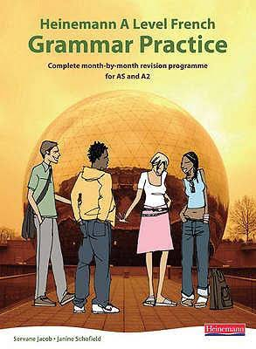It could be very helpful for you to have a textbook to practise newly studied grammar.

* **Heinemann A Level French Grammar Practice -** *Heinemann A Level French Grammar Practice* is a very well-made revision book cover a range of grammar. It is a very good tool to consolidate the learning that we will do in class.

**Vocabulary building**

Write down below some new vocabulary that you learn as you visit the websites, use the apps, listen to the podcasts or watch the films and series mentioned above:

|  |  |
| --- | --- |
| __________________________________________ | __________________________________________ |
| __________________________________________ | __________________________________________ |
| __________________________________________ | __________________________________________ |
| __________________________________________ | __________________________________________ |
| __________________________________________ | __________________________________________ |
| __________________________________________ | __________________________________________ |
| __________________________________________ | __________________________________________ |
| __________________________________________ | __________________________________________ |
| __________________________________________ | __________________________________________ |
| __________________________________________ | __________________________________________ |
| __________________________________________ | __________________________________________ |
| __________________________________________ | __________________________________________ |
| __________________________________________ | __________________________________________ |
| __________________________________________ | __________________________________________ |
| __________________________________________ | __________________________________________ |
| __________________________________________ | __________________________________________ |
| __________________________________________ | __________________________________________ |
| __________________________________________ | __________________________________________ |
| __________________________________________ | __________________________________________ |
| __________________________________________ | __________________________________________ |
| __________________________________________ | __________________________________________ |
| __________________________________________ | __________________________________________ |
| __________________________________________ | __________________________________________ |
| __________________________________________ | __________________________________________ |
| __________________________________________ | __________________________________________ |

**Review**

As you watch some of the films and series, or listen to the podcasts mentioned above (or other that you have found yourself), write a quick review about it in the tables below

|  |  |  |  |  |
| --- | --- | --- | --- | --- |
| **Titre** | | | **Genre** | |
| **une étoile** | **Five-pointed star - Wikipedia**  **deux étoiles** | **Five-pointed star - WikipediaFive-pointed star - Wikipedia**  **trois étoiles** | **Five-pointed star - WikipediaFive-pointed star - WikipediaFive-pointed star - Wikipedia**  **quatre étoiles** | **Five-pointed star - WikipediaFive-pointed star - WikipediaFive-pointed star - WikipediaFive-pointed star - Wikipedia**  **cinq étoiles** |
| **Commentaire** *(in French or in English, write your opinion, what you liked or disliked about it)* **:**  **______________________________________________________________________________________________________________________________________________________________________________________________________________________________________________________________________________________________________________________________________________________________________________________________________________________________________________** | | | | |

|  |  |  |  |  |
| --- | --- | --- | --- | --- |
| **Titre** | | | **Genre** | |
| **Five-pointed star - Wikipedia**  **une étoile** | **Five-pointed star - WikipediaFive-pointed star - Wikipedia**  **deux étoiles** | **Five-pointed star - WikipediaFive-pointed star - WikipediaFive-pointed star - Wikipedia**  **trois étoiles** | **Five-pointed star - WikipediaFive-pointed star - WikipediaFive-pointed star - WikipediaFive-pointed star - Wikipedia**  **quatre étoiles** | **Five-pointed star - WikipediaFive-pointed star - WikipediaFive-pointed star - WikipediaFive-pointed star - WikipediaFive-pointed star - Wikipedia**  **cinq étoiles** |
| **Commentaire** *(in French or in English, write your opinion, what you liked or disliked about it)* **:**  **______________________________________________________________________________________________________________________________________________________________________________________________________________________________________________________________________________________________________________________________________________________________________________________________________________________________________________** | | | | |

|  |  |  |  |  |
| --- | --- | --- | --- | --- |
| **Titre** | | | **Genre** | |
| **Five-pointed star - Wikipedia**  **une étoile** | **Five-pointed star - WikipediaFive-pointed star - Wikipedia**  **deux étoiles** | **Five-pointed star - WikipediaFive-pointed star - WikipediaFive-pointed star - Wikipedia**  **trois étoiles** | **Five-pointed star - WikipediaFive-pointed star - WikipediaFive-pointed star - WikipediaFive-pointed star - Wikipedia**  **quatre étoiles** | **Five-pointed star - WikipediaFive-pointed star - WikipediaFive-pointed star - WikipediaFive-pointed star - WikipediaFive-pointed star - Wikipedia**  **cinq étoiles** |
| **Commentaire** *(in French or in English, write your opinion, what you liked or disliked about it)* **:**  **______________________________________________________________________________________________________________________________________________________________________________________________________________________________________________________________________________________________________________________________________________________________________________________________________________________________________________** | | | | |

**Present tense verbs practice – Regular and Irregular verbs**

**Regular -ER verbs**

**Translate these sentences into English.**

1. Nous gaspillons les ressources de la Terre.
2. Le gouvernement sensibilise le grand public aux problèmes de l’économie.
3. La manifestation tourne au drame quand les émeutiers commencent à crier des slogans anti-gouvernementaux.
4. Il gère bien ses affaires.
5. Vous sous-estimez le talent de votre équipe.
6. La police ignore tout de la décision du gouvernement.
7. Ils se déplacent toujours à vélo.

**Translate these sentences into French, paying particular attention to the correct form.**

1. He wastes his money.
2. They waste too many resources.
3. We are making people aware of the problem.
4. They are making the general public aware.
5. I manage my money.
6. They manage the company.
7. They underestimate the problem.
8. The government is unaware of the problem.
9. Most French people travel by car.
10. The situation takes a dramatic turn.

**Regular -IR verbs**

**Translate these sentences into English.**

1. Il agit tout seul.
2. Les manifestants agissent avec violence.
3. Tu grossis un peu.
4. Le gouvernement abolit le droit de manifester.
5. Les élèves issus de la classe moyenne réussissent mieux à l’école.
6. Vous maigrissez ?
7. Je réussis mieux à l’école quand je me concentre.
8. Réfléchissez bien avant d’aller sur Facebook !

**Translate these sentences into French, paying particular attention to the correct form.**

1. The government acts against the students.
2. You (plural) act with the government.
3. I am putting on a bit of weight.
4. They are putting on weight.
5. The pupil succeeds at school.
6. The students succeed at university.
7. They are abolishing the right to demonstrate.
8. The man thinks (reflects).
9. The government is establishing a new system.
10. Everybody chooses.

**Regular -RE verbs**

**Translate these sentences into English.**

1. Vous attendez le bus ?
2. Je te défends de manger trop de sucre.
3. Le gouvernement prétend que les manifestants sont trop violents.
4. Tu entends ce bruit ?
5. Nous perdons beaucoup d’argent ces jours-ci ?

**Translate these sentences into French, paying particular attention to the correct form.**

1. He claims that the government is acting dishonestly.
2. I lose my keys every day.
3. You (plural) are losing your money.
4. The man does not reply.
5. The students reply.
6. You (singular) learn French grammar.
7. They are waiting for a reply.
8. The teacher is waiting for the pupils.
9. 50% of French people claim that it’s not true.
10. Everybody is waiting for the good weather.

**Irregular verbs**

**Fill in the gaps with the correct form of the verbs in the present tense.**

1. Qu’est-ce que vous **____________** ? *(faire)*
2. Je **____________** avec mon mari et mes deux enfants. *(vivre)*
3. Je **____________** une belle voiture. *(conduire)*
4. Ils **____________** des cartes postales. *(écrire)*
5. Vous **____________** toujours la vérité. *(dire)*
6. Ils **____________** beaucoup de choses. *(faire)*
7. Nous **____________** beaucoup de livres chez nous. *(lire)*
8. Tu **____________** de l’alcool ? *(boire)*
9. Qu’est-ce qu’ils **____________** ? *(vouloir)*
10. Ils ne **____________** rien, eux ! *(savoir)*
11. Je lui **____________** un beau cadeau. *(offrir)*
12. Tu **____________** vite ? *(courir)*
13. Ils **____________** ici souvent ? *(venir)*
14. Nous ne **____________** rien de ce qui s’est passé. *(savoir)*
15. Où **____________**-tu ce soir ? *(dormir)*

**Translate these sentences into French, paying particular attention to the correct form.**

1. What are you doing? *(singular)*
2. My mum drives a red Porsche.
3. I run every day.
4. They drink coffee at breakfast.
5. We want to go to Paris.
6. We read a lot of books.
7. Do you go out a lot? *(plural)*
8. I must write a letter.
9. I write letters every day.
10. They take breakfast at 8 o’clock every day.

**Complete the table with the missing forms of these irregular verbs.**

|  |  |  |  |  |
| --- | --- | --- | --- | --- |
| **être** – to be | **avoir** – to have | **aller** – to go | **faire** – to do | **devoir** – to have to |
| je _________  tu es  il/elle/on est  nous _________  vous êtes  ils/elles _________ | j’ai  tu _________  il/elle/on _________  nous avons  vous _________  ils/elles ont | je _________  tu _________  il/elle/on va  nous allons  vous allez  ils/elles _________ | je _________  tu fais  il/elle/on fait  nous _________  vous _________  ils/elles font | je dois  tu _________  il/elle/on doit  nous _________  vous devez  ils/elles _________ |
| **vouloir** – to want | **pouvoir** – o be able to | **savoir** – to know | **connaître** – to know | **prendre** – to take |
| je veux  tu _________  il/elle/on _________  nous voulons  vous voulez  ils/elles _________ | je _________  tu peux  il/elle/on _________  nous pouvons  vous _________  ils/elles peuvent | je sais  tu sais  il/elle/on _________  nous _________  vous _________  ils/elles savent | je _________  tu connais  il/elle/on connait  nous _________  vous connaissez  ils/elles _________ | je prends  tu _________  il/elle/on prend  nous _________  vous _________  ils/elles prennent |
| **écrire** – to write | **lire** – to read | **dire** – to say | **vivre** – to live | **courir** – to run |
| j’écris  tu _________  il/elle/on _________  nous écrivons  vous écrivez  ils/elles _________ | je _________  tu lis  il/elle/on lit  nous _________  vous lisez  ils/elles _________ | je _________  tu _________  il/elle/on dit  nous disons  vous dites  ils/elles _________ | je vis  tu vis  il/elle/on _________  nous _________  vous vivez  ils/elles _________ | je _________  tu _________  il/elle/on court  nous courons  vous _________  ils/elles courent |
| **sortir** – to go out | **dormir** – to sleep | **servir** – to serve | **venir** – to come | **voir** – to see |
| je sors  tu sors  il/elle/on _________  nous _________  vous sortez  ils/elles _________ | je _________  tu dors  il/elle/on _________  nous _________  vous dormez  ils/elles dorment | je _________  tu sers  il/elle/on sert  nous _________  vous servez  ils/elles _________ | je _________  tu viens  il/elle/on vient  nous _________  vous venez  ils/elles _________ | je _________  tu vois  il/elle/on _________  nous voyons  vous _________  ils/elles voient |
| **boire** – to drink | **croire** – to believe | **espérer** – to hope | **essayer** – to try | **partager** – to share |
| je _________  tu bois  il/elle/on boit  nous _________  vous buvez  ils/elles _________ | je crois  tu _________  il/elle/on croit  nous _________  vous croyez  ils/elles _________ | j’_________  tu espères  il/elle/on _________  nous espérons  vous espérez  ils/elles _________ | j’_________  tu essaies  il/elle/on essaie  nous _________  vous essayez  ils/elles _________ | je partage  tu _________  il/elle/on partage  nous _________  vous partagez  ils/elles _________ |

**Content and grammatical activities**

**Developing ideas**

You will be asked about your opinions on a variety of topics in the A-Level French course, and it is a good idea to start developing an opinion on a range of subjects now. Putting those ideas down on paper can be an even more challenging task. Look at the topic below and write down 3 arguments for and 3 arguments against (first in English, then try it out in French). It’s fine to ask parents and friends, just get used to thinking about this type of issues:

1. Cheap fashion

________________________________________________________________________________________________________________________________________________________________________________________________________________________________________________________________________

1. A smoking ban in private cars

________________________________________________________________________________________________________________________________________________________________________________________________________________________________________________________________________

1. No free health care for the obese

________________________________________________________________________________________________________________________________________________________________________________________________________________________________________________________________________

1. Living with one’s parents at the age of 25.

________________________________________________________________________________________________________________________________________________________________________________________________________________________________________________________________________

1. Homosexual marriage *(made legal in France in April 2013)*

________________________________________________________________________________________________________________________________________________________________________________________________________________________________________________________________________

1. A law that stipulates that immigrants have to learn the language of the country they settle in

________________________________________________________________________________________________________________________________________________________________________________________________________________________________________________________________________

**Word formation**

As discussed earlier in this booklet, you should get in the habit of writing down vocabulary and examining new words to find out what noun, verb, adjective or adverb derive from it. Observe how the following words relate to each other for instance:

|  |  |
| --- | --- |
| **Nom** | **Verbe** |
| l’augmentation | augmenter |
| *the increase* | *to increase* |

|  |  |  |
| --- | --- | --- |
| **Nom** | **Adjectif** | **Adverbe** |
| l’amour | amoureux(euse) | amoureusement |
| *the love* | *in love* | *lovingly* |

|  |  |  |  |
| --- | --- | --- | --- |
| **Nom** | **Verbe** | **Adjectif** | **Adverbe** |
| la solidité | consolider | solide | solidement |
| *solidity* | *to consolidate* | *solid* | *solidly* |

Notice all nouns have a verb deriving from it, or an adjective, or an adverb.

Complete the table below by including the missing words

|  |  |  |  |
| --- | --- | --- | --- |
| **Nom** | **Verbe** | **Adjectif** | **Adverbe** |
|  | libérer |  |  |
| *the liberty* | *to to liberate, free* | *free* | *freely* |

|  |  |  |
| --- | --- | --- |
| **Nom** | **Adjectif** | **Adverbe** |
| le fou, la folle |  | follement |
| *the crazy (person)* | *crazy* | *crazily* |

|  |  |  |  |
| --- | --- | --- | --- |
| **Nom** | **Verbe** | **Adjectif** | **Adverbe** |
|  | désespérer |  | désespérément |
| *the despair* | *to despair* | *desparate* | *desparately* |

|  |  |  |  |
| --- | --- | --- | --- |
| **Nom** | **Verbe** | **Adjectif** | **Adverbe** |
| la force |  | fort(e) |  |
| *the force, strength* | *to force* | *strong* | *strongly* |

|  |  |
| --- | --- |
| **Nom** | **Adjectif** |
|  | humoristique |
| *humour* | *humourous* |

|  |  |  |  |
| --- | --- | --- | --- |
| **Nom** | **Verbe** | **Adjectif** | **Adverbe** |
| la régulation |  | régulier(ère) |  |
| *the regulation* | *to regulate* | *regular* | *regularly* |

|  |  |  |
| --- | --- | --- |
| **Nom** | **Adjectif** | **Adverbe** |
| la méchanceté |  | méchamment |
| *the meanness* | *mean* | *meanly* |

|  |  |
| --- | --- |
| **Nom** | **Verbe** |
| l’espoir |  |
| *the hope* | *to hope* |

**Reading comprehension**

Read the text below and write a quick summary of the text as well as some new words that you learn.

Croque-monsieur

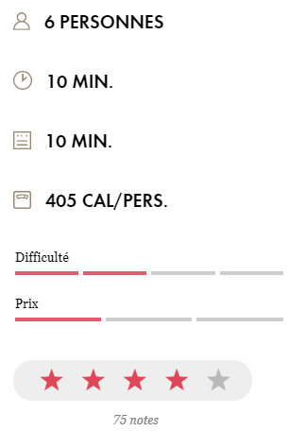[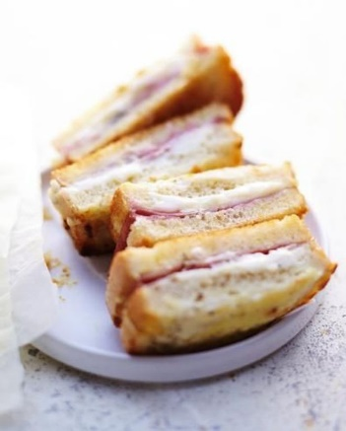](https://cdn-elle.ladmedia.fr/var/plain_site/storage/images/elle-a-table/recettes-de-cuisine/croque-monsieur-2280962/26592320-3-fre-FR/Croque-monsieur.jpeg)La recette classique du bistrot !

**INGRÉDIENTS**

* Pour la [béchamel](https://www.elle.fr/Elle-a-Table/Ingredients/bechamel) :
* 50 g de [beurre](https://www.elle.fr/Elle-a-Table/Ingredients/beurre)
* 50 g de [farine](https://www.elle.fr/Elle-a-Table/Ingredients/farine)
* 1 l de [lait](https://www.elle.fr/Elle-a-Table/Ingredients/lait)
* sel
* poivre du moulin
* [noix](https://www.elle.fr/Elle-a-Table/Ingredients/noix) [muscade](https://www.elle.fr/Elle-a-Table/Ingredients/muscade)
* Pour les croques
* 12 tranches de [pain](https://www.elle.fr/Elle-a-Table/Ingredients/pain)
* 2 cuillère(s) à soupe de moutarde
* 12 très fines tranches de [jambon](https://www.elle.fr/Elle-a-Table/Ingredients/jambon) aux herbes à l'italienne
* 80 g de [fromage](https://www.elle.fr/Elle-a-Table/Ingredients/fromage) râpé (emmental, [comté](https://www.elle.fr/Elle-a-Table/Ingredients/comte) [gruyère](https://www.elle.fr/Elle-a-Table/Ingredients/gruyere) mimolette

**PRÉPARATION**

* **1.** Préparez la béchamel : faites fondre le beurre dans une casserole à fond épais.
* **2.** Dès qu’il mousse, saupoudrez-le de farine, salez, poivrez, ajoutez une pointe de couteau de noix muscade, mélangez.
* **3.** Puis versez le lait, petit à petit (surtout pas en une seule fois), en remuant avec un fouet à chaque fois, jusqu’à ce que la sauce épaississe.
* **4.** Allumez le four sur th. 6/180°, sortez la plaque du four et tapissez-la d’une feuille d’aluminium.
* **5.** Etalez six tranches de pain devant vous, tartinez-les d’un peu de moutarde, ajoutez une couche de béchamel, 1 tranche de jambon pliée en quatre, du fromage râpé, une couche de béchamel, posez les six autres tranches de pain par-dessus, ajoutez une fine couche de béchamel et répartissez le reste de fromage râpé.
* **6.** Rangez les croque-monsieur sur la plaque et passez-les au four environ 10 mn.
* **7.** Vous pouvez les passer sous le gril du four 3-4 mn à la fin.

**L'ASTUCE**

Vous pouvez préparer les croque-monsieur à l’avance et les passer au four au dernier moment.

|  |
| --- |
| **Résumé :** |
| **Nouveau vocabulaire :** |

**Reading comprehension**

Read the text below and write a quick summary of the text as well as some new words that you learn.

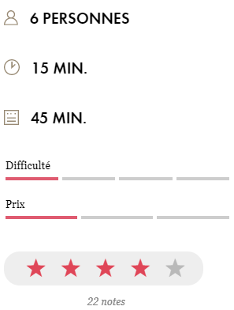[](https://cdn-elle.ladmedia.fr/var/plain_site/storage/images/elle-a-table/recettes-de-cuisine/tarte-tatin2/16410588-2-fre-FR/Tarte-Tatin.jpg)Tarte Tatin

**INGRÉDIENTS**

* 1 rouleau de [pâte](https://www.elle.fr/Elle-a-Table/Ingredients/pate) feuilletée
* 8 [pommes](https://www.elle.fr/Elle-a-Table/Ingredients/pomme) golden bien jaunes
* 100 g de [beurre](https://www.elle.fr/Elle-a-Table/Ingredients/beurre)
* 100 g de [sucre](https://www.elle.fr/Elle-a-Table/Ingredients/sucre) en poudre
* 2 sachets de [sucre](https://www.elle.fr/Elle-a-Table/Ingredients/sucre) vanillé
* quelques pincées de [cannelle](https://www.elle.fr/Elle-a-Table/Ingredients/cannelle)

**PRÉPARATION**

* **1.** Allumez le four à 180° (th. 6). Epluchez les pommes entières, coupez-les en deux, enlevez le coeur et reconstituez-les.
* **2.** Faites fondre le beurre dans un moule à manqué. Ajoutez le sucre en poudre, et laissez cuire jusqu’à obtention d’un caramel ambré. Disposez les pommes reconstituées en couronne dans le plat.
* **3.** Laissez cuire les pommes 10 mn environ en les aplatissant légèrement avec une spatule de temps en temps : elles doivent pocher dans le caramel, qui ne doit pas devenir noir, mais rester doré.
* **4.** Saupoudrez les pommes de sucre vanillé et de cannelle. Retirez du feu et couvrez de pâte feuilletée en appuyant bien sur les bords. Glissez au four et laissez cuire 35 à 40 mn : la pâte doit être dorée.
* **5.** Retournez la tarte sur un plat de service et dégustez tiède.

**L'ASTUCE**

Accompagnez d’un verre de liqueur, corse si possible : cédrat, mandarine, myrte, châtaigne...

|  |
| --- |
| **Résumé :** |
| **Nouveau vocabulaire :** |

**Reading comprehension**

Read the text below and write a quick summary of the text as well as some new words that you learn.

[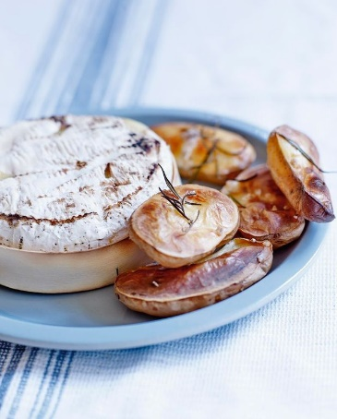](https://cdn-elle.ladmedia.fr/var/plain_site/storage/images/elle-a-table/recettes-de-cuisine/camembert-au-four-et-pommes-soufflees-2596810/42438320-1-fre-FR/Camembert-au-four-et-pommes-soufflees.jpg)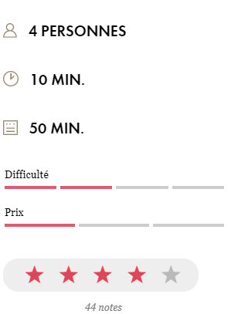Camembert au four et pommes soufflées

**INGRÉDIENTS**

* 1 [camembert](https://www.elle.fr/Elle-a-Table/Ingredients/camembert) au [lait](https://www.elle.fr/Elle-a-Table/Ingredients/lait) cru pas trop fait
* 12 petites [pommes](https://www.elle.fr/Elle-a-Table/Ingredients/pomme) de terre à chair ferme (type pompadour)
* 1 branche de [romarin](https://www.elle.fr/Elle-a-Table/Ingredients/romarin)
* gros sel

**PRÉPARATION**

* **1.** Préchauffez le four sur th. 6/180°.
* **2.** Lavez les pommes de terre, essuyez-les et coupez-les en deux.
* **3.** Rangez-les sur une plaque de four, parsemez de gros sel et de romarin émietté. Mettez au four pendant 45 mn. Les pommes de terre doivent être gonflées et dorées, au besoin allongez le temps de cuisson de 10 à 15 mn.
* **4.** Sortez-les et placez le four sur la position grill. Retirez le papier qui entoure le camembert, remettez le fromage dans sa boîte sans le couvercle et placez-le sous le grill 4 à 5 mn, le temps qu’il fonde à l’intérieur et grille à l’extérieur.
* **5.** Servez le camembert avec des cuillères, accompagné des demi-pommes de terre soufflées.

**L'ASTUCE**

Plus économique qu’un vacherin et tout aussi délicieux.  
Choisissez bien votre camembert qui ne doit pas être trop affiné, pour une fois !

|  |
| --- |
| **Résumé :** |
| **Nouveau vocabulaire :** |

**Reading comprehension**

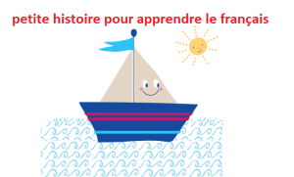Read the text below and write a quick summary of the text as well as some new words that you learn.

C’est l’histoire d’un petit bateau qui est parti depuis bien longtemps sur les mers. Au cours de son voyage, il a vu des paysages fantastiques avec des arbres de toutes les couleurs… Au cours de son voyage, il a senti des odeurs merveilleuses qu’il ne connaissait pas auparavant.

Au cours de son voyage, il a écouté de jolies mélodies chantées par des oiseaux rouges et verts… Aujourd’hui, c’est l’heure de rentrer au port… De rentrer au port où il pourra enfin se reposer de son long voyage. Il s’avance lentement, heureux de reconnaître le paysage… Il reconnait les petites maisons bleues du port. Il reconnait les douces odeurs de son enfance. Il reconnait la couleur de l’eau si particulière à cet endroit.

Le petit bateau continue à se rapprocher du port, et il arrive enfin à sa place… la place qui est la sienne… dans ce si joli petit port… Il accroche une corde d’abordage à un des anneaux du port. Il peut maintenant se détendre complètement… Il est en par- faite sécurité. Il est tellement heureux d’être enfin arrivé, qu’il sent un grand calme l’envahir… de la tête aux pieds. C’est si bon de pouvoir arrêter de courir. C’est si bon de pouvoir se reposer.

Le petit bateau regarde autour de lui, il découvre de jolies choses et d’autres choses encore… il sent que les vagues le bercent doucement, tout doucement, et il se laisse aller à rêver agréablement à son magnifique voyage. Il repense à toutes les choses agréables qu’il a faites, et très naturellement ses yeux se ferment… et il commence à laisser son esprit se promener ; et il continue comme cela, de plus en plus lentement. Il sait qu’après s’être reposé, il pourra repartir pour un joli voyage… et il commence à rêver à son prochain voyage en se laissant bercer par le doux mouvement des vagues.…

|  |
| --- |
| **Résumé :** |
| **Nouveau vocabulaire :** |

**Reading comprehension**

Read the text below and write a quick summary of the text as well as some new words that you learn.

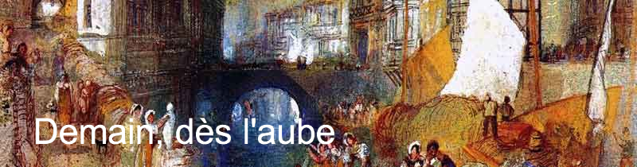  
**Demain dès l’aube (Victor Hugo, les Contemplations, 1847)**

Demain, dès l’aube, à l’heure où blanchit la campagne,  
Je partirai. Vois-tu, je sais que tu m’attends.  
J’irai par la forêt, j’irai par la montagne.  
Je ne puis* demeurer loin de toi plus longtemps.

Je marcherai les yeux fixés sur mes pensées,  
Sans rien voir au dehors, sans entendre aucun bruit,  
Seul, inconnu, le dos courbé, les mains croisées,  
Triste, et le jour pour moi sera comme la nuit.

Je ne regarderai ni l’or du soir qui tombe,  
Ni les voiles au loin descendant vers Harfleur,  
Et quand j’arriverai, je mettrai sur ta tombe  
Un bouquet de houx vert et de bruyère en fleur.

*\* je ne peux pas*

|  |
| --- |
| **Résumé :** |
| **Nouveau vocabulaire :** |

**Reading comprehension**

Read the text below and write a quick summary of the text as well as some new words that you learn.

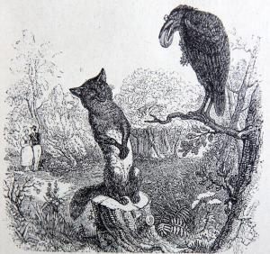

**Le corbeau et le renard (Jean de la Fontaine, 1668)**

Maître corbeau, sur un arbre perché,

Tenait en son bec un fromage.

Maître renard, par l’odeur alléché,

Lui tint à peu près ce langage :

« Hé ! bonjour Monsieur du Corbeau.

Que vous êtes joli ! que vous me semblez beau !

Sans mentir, si votre ramage

Se rapporte à votre plumage,

Vous êtes le phénix des hôtes de ces bois. »

A ces mots, le corbeau ne se sent pas de joie ;

Et pour montrer sa belle voix,

Il ouvre un large bec, laisse tomber sa proie.

Le renard s’en saisit, et dit : « Mon bon monsieur,

Apprenez que tout flatteur

Vit aux dépens de celui qui l’écoute.

Cette leçon vaut bien un fromage sans doute. »

Le corbeau honteux et confus,

Jura, mais un peu tard, qu’on ne l’y prendrait plus.

|  |
| --- |
| **Résumé :** |
| **Nouveau vocabulaire :** |

**Reading comprehension**

Read the text below and write a quick summary of the text as well as some new words that you learn.

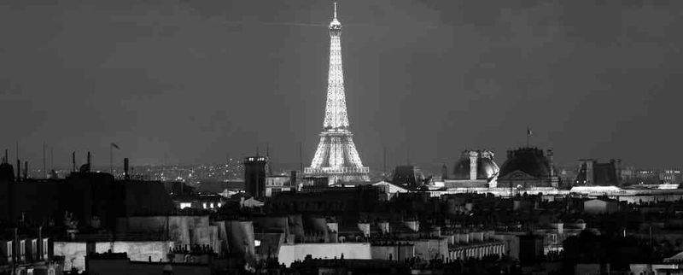**Paris at night (Jacques Prévert)**

Trois allumettes, une à une allumées dans la nuit

La première pour voir ton visage tout entier

La seconde pour voir tes yeux

La dernière pour voir ta bouche

et l’obscurité tout entière pour me rappeler tout cela

en te serrant dans mes bras.

|  |
| --- |
| **Résumé :** |
| **Nouveau vocabulaire :** |

**Reading comprehension**

Read the text below and write a quick summary of the text as well as some new words that you learn.



**La Bise n’est pas aussi simple qu’elle n’y paraît**

Bon, tout le monde sait qu’en France, on se fait la bise pour se dire bonjour. Maintenant, un problème commun qu’on rencontre c’est : combien de bises je fais ? Particulièrement quand on rencontre d’autres français venant d’une région différente, il y a toujours ce moment de flottement ou on ne sait pas s’ils font partie du même « clan » que nous. Généralement c’est deux bises, mais certaines régions en font trois (comme chez moi par exemple), et ça peut monter jusqu’à cinq ! Si ce n’était qu’une question de quantité ça irait encore… mais le côté par lequel on commence est aussi différent. Par exemple : là où j’habite on fait trois bises en commençant par la joue gauche, à Lyon ils en font deux en commençant à gauche, mais à Paris c’est deux bises en commençant à droite… Et ça change pour chaque région ! Vous n’êtes pas pleinement français tant que vous n’avez pas vécu ce moment gênant à attendre la troisième bise qui ne vient jamais…

|  |
| --- |
| **Résumé :** |
| **Nouveau vocabulaire :** |

**Reading comprehension**

Read the text below and write a quick summary of the text as well as some new words that you learn.

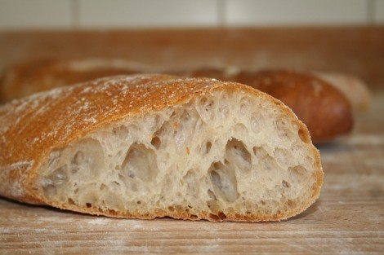

**Une baguette n’est pas « que » du pain**

Pour les francophones non-français (et pour le reste du monde d’ailleurs), n’importe quel pain qui ressemblerait de près ou de loin à une baguette est appelé une baguette (surtout chez les anglophones en fait). Mais je vous en supplie, une baguette n’est pas n’importe quel type de pain. D’après la loi française (oui, on a une loi là-dessus), une baguette n’est faite que de farine, levure, sel et eau. Elle ne peut peser plus de 250g, et traditionnellement. Elle fait 5cm de large, 3cm de haut et 65cm de long (mais on n’est pas aux pièces, hein !). En vérité, on a d’autres mots pour les autres types de pains, comme flûte (plus large qu’une baguette), ficelle (plus fine qu’une baguette), ou juste un pain (plus long et large qu’une baguette, mais se réfère aussi à un pain rond), etc. Après, il ne faut pas non plus oublier le fait que chaque type de pain peut être complet, rustique, traditionnel, aux céréales, etc… Je vous le dis, le pain ici c’est plus qu’un truc à manger, c’est presque une religion !

|  |
| --- |
| **Résumé :** |
| **Nouveau vocabulaire :** |

**Reading comprehension**

Read the text below and write a quick summary of the text as well as some new words that you learn.

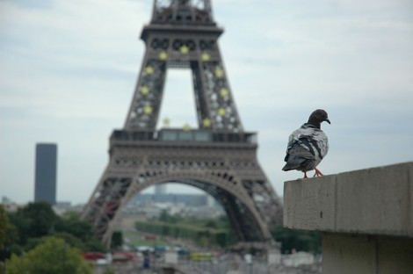

**L’armée Française est la seule d’Europe à encore compter des pigeons voyageurs dans ses rangs.**

Il y a actuellement 150 pigeons voyageurs dans l’armée française. Il a été dit qu’en cas de « catastrophe majeure », ce serait le seul moyen de communication efficace. J’imagine que ce n’est pas faux… On devrait faire pareil dans les entreprises pour le jour où le serveur est en panne et qu’on ne peut plus envoyer d’emails.

|  |
| --- |
| **Résumé :** |
| **Nouveau vocabulaire :** |

**Faits sur la France**

* La France est le plus grand pays de l’Union Européenne
* Il y a plus de francophones en Afrique qu’en Europe
* La France détient le record mondial du nombre de rond-point
* Il existe entre 300 et 500 types de fromage différents en France
* Complétée en 1889, la Tour Eiffel a été le plus grand monument construit par l’homme au monde pendant 41 ans
* Ne mettez jamais une baguette à l’envers sur la table en France
* La France est le pays le plus visité du monde
* La France est connue pour ses parfums dans le monde entier
* La devise de la France est Liberté, Egalité, Fraternité
* Il y a environ 40000 châteaux en France
* La France est connue sous le nom de l’Hexagone à cause de sa forme hexagonale
* Environ 40% des immigrants vivent en Île-de-France